School Counseling Program Newsletter
Shandrai Silva, School Counselor | January 2019

Counselor Message  Happy New Year! The beginning of a new year is an exciting time - one of reflection, goal-setting and redefining.  The school counseling program looks forward to fantastic second half of the school year. Please feel free to share any ideas you may have as we move forward.  In December, the school counseling program continued with classroom guidance lessons on Digital Citizenship. Students also engaged in lessons on kindness and empathy.  This month, the school counseling program will continue to provide classroom lessons, small group counseling and individual meetings with students. In January, we’re recognizing No Name Calling Week, National Mentoring Month and The Great Kindness Challenge.  Looking forward to a great 2019!  __________________________  How to see the school counselor  Classroom guidance classes are weekly based on grade level specials schedule. Small group counseling and individual counseling by self -referral, parent referral, teacher referral, administrator referral or counselor initiated.  Contact School Counselor at 704-866-8467or sosilva@gaston.k12.nc.us.  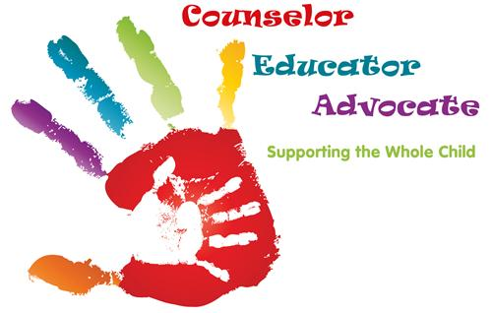 | Home of the Hawks    Kindness in Action  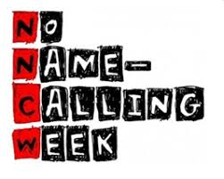  January 21st - 25th  GCS Kindness Challenge Week 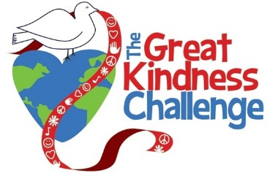Jan. 28 – Feb. 1, 2019  *Wear Yellow on Jan. 31st  https://thegreatkindnesschallenge.com/schooledition/  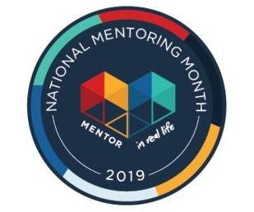  Thank You Mentors! | Character Education  “We’re Soaring with Good Character”  ______________________________  The character trait of the month is Perseverance.  Perseverance means a steady will to complete a task in spite of any obstacles before you. Students will have an opportunity to learn more about perseverance through morning announcements and classroom activities.  _____________________________  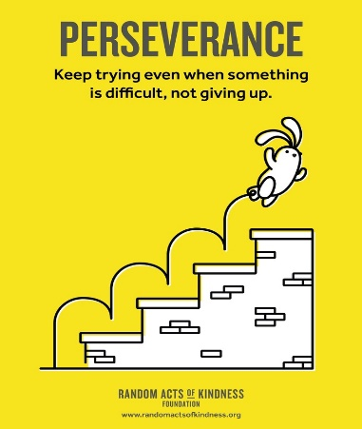  Poster found at Random Acts of Kindness  https://www.randomactsofkindness.org/printables  Resilient Kids that Never Give Up…  - Have a supportive role model- model resilient behavior, be calm and consistent, admit your mistakes and talk about how to you’ll get better.  - Are allowed to make mistakes- let them see consequences of their behavior, give them a chance to bounce back and learn from their behavior.  - Are praised the right way- give process praise where you focus on strategies, process or effort.  - Are taught to manage their emotions- teach that all emotions are normal, healthy ways to deal with emotions and fix problems.  - Are taught to problem solve- don’t rush to solve problems for them, brainstorm ways to address challenges and possible consequences of each solution.  https://biglifejournal.com/blogs/blog/how-to-raise-resilient-kids-who-never-give-up

